As of 2024, several hobbyist Inertial Measurement Units (IMUs) have gained popularity due to their accessibility, performance, and community support. Here are some of the most notable ones:

1. **MPU-6050**: A widely used IMU that combines a 3-axis gyroscope and a 3-axis accelerometer. It's popular for projects involving drones and robotics due to its affordability and ease of use.

2. **BNO055**: This sensor offers a 9-axis absolute orientation sensor that integrates accelerometer, gyroscope, and magnetometer data. Its built-in sensor fusion makes it a favorite for applications requiring orientation tracking.

3. **LSM6DS3**: This IMU features a 3-axis accelerometer and 3-axis gyroscope with high performance. It’s known for its low power consumption, making it ideal for battery-operated devices.

4. **MPU-9250**: An upgrade from the MPU-6050, it adds a 3-axis magnetometer for full 9-axis motion tracking. It’s widely used in robotics and drone applications.

5. **ICM-20948**: This is another popular choice that includes a 9-axis IMU with good performance and a built-in digital motion processor for enhanced data processing.

6. **LIS3MDL**: While primarily a magnetometer, it’s often used in conjunction with other IMUs to provide a comprehensive orientation solution.

7. **Adafruit 9-DOF Absolute Orientation IMU**: This board combines the BNO055 with additional features and is well-regarded in the hobbyist community for its user-friendly interface and documentation.

These IMUs are commonly used in various applications, from robotics to motion tracking and augmented reality, making them excellent choices for hobbyists looking to integrate motion sensing into their projects.

Yes, Pololu offers a few IMU options that are popular among hobbyists. Some notable ones include:

1. **Pololu MinIMU-9 v5**: This compact board features an LSM6DS33 6-axis IMU (accelerometer and gyroscope) and an LSM303C magnetometer, providing 9-axis motion sensing. It’s well-regarded for its small size and ease of integration.

2. **Pololu AltIMU-10 v5**: This is a more advanced IMU that includes an LSM6DS33 6-axis IMU and an LPS25H barometer. It’s designed for applications requiring altitude measurement in addition to motion tracking. NOTE: replaced by AltIMU-10 v6 Gyro, Accelerometer, Compass, and Altimeter (LSM6DSO, LIS3MDL, and LPS22DF Carrier)

3. **Pololu BNO055 IMU**: This is based on the BNO055 sensor, which offers integrated sensor fusion for more straightforward orientation tracking. It’s great for projects that need reliable and accurate orientation data.

Pololu's IMUs are well-documented and come with libraries, making them accessible for hobbyists and beginners looking to work with motion sensing.

As of 2024, Adafruit has several popular IMUs that hobbyists frequently use:

1. **Adafruit BNO055 9-DOF IMU**: This sensor provides absolute orientation with integrated sensor fusion, making it easy to use for projects that require reliable heading and tilt information.

2. **Adafruit LSM6DS33 + LIS3MDL 9-DOF IMU**: This combination includes a 6-axis IMU (accelerometer and gyroscope) paired with a magnetometer. It's known for its versatility and is often used in robotics and wearable projects.

3. **Adafruit MPU6050 6-DOF IMU**: This classic IMU combines a 3-axis accelerometer and a 3-axis gyroscope. It's popular for its simplicity and low cost, making it ideal for many beginner projects.

4. **Adafruit ICM-20948 9-DOF IMU**: This sensor features a 3-axis accelerometer, 3-axis gyroscope, and 3-axis magnetometer, providing robust motion sensing capabilities.

5. **Adafruit LSM9DS1 9-DOF IMU**: This IMU combines a 3-axis accelerometer, 3-axis gyroscope, and 3-axis magnetometer, and is favored for its high performance and small form factor.

Adafruit’s offerings are well-documented with libraries and tutorials, making them accessible and user-friendly for hobbyists and makers.

es, Bosch produces several popular IMUs that are widely used in various applications, particularly in consumer electronics, automotive, and industrial sectors. Some of their notable IMUs include:

1. **BNO055**: This 9-axis sensor integrates an accelerometer, gyroscope, and magnetometer, and is known for its advanced sensor fusion capabilities, making it great for applications requiring orientation tracking.
2. **BMI088**: This is a high-performance 6-axis IMU with a 3-axis accelerometer and a 3-axis gyroscope. It's designed for applications that require high stability and low drift, such as drones and robotics.
3. **BMI160**: Another popular choice, this 6-axis IMU is energy-efficient and features a 3-axis accelerometer and gyroscope. It’s often used in mobile devices and wearable technology.
4. **BMA400**: Although primarily an accelerometer, it’s known for its low power consumption and is often integrated with other sensors for motion detection applications.
5. **BMG250**: This is a low-power gyroscope that can be used in conjunction with other Bosch accelerometers for motion sensing applications.

Bosch IMUs are well-regarded for their performance and reliability, making them a popular choice among engineers and hobbyists alike.

STMicroelectronics offers a range of popular IMUs that are widely used in various applications, especially in consumer electronics, robotics, and IoT. Here are some of their notable IMUs:

1. **LSM6DSL**: This is a 6-axis IMU combining a 3-axis accelerometer and a 3-axis gyroscope. It features low power consumption and is suitable for wearable devices and mobile applications.
2. **LSM6DS3**: Another 6-axis IMU, it offers high performance and comes with built-in machine learning capabilities, making it suitable for advanced applications in robotics and motion detection.
3. **LSM9DS1**: This is a 9-axis IMU that includes a 3-axis accelerometer, 3-axis gyroscope, and 3-axis magnetometer. It’s popular for applications that require comprehensive motion tracking.
4. **LSM6DSOX**: This newer 6-axis IMU includes features like machine learning and is optimized for ultra-low power consumption, making it ideal for battery-operated devices.
5. **ISM330DHCX**: This advanced 6-axis IMU is designed for high-performance applications and includes features for enhanced accuracy and robustness in motion sensing.

STMicroelectronics' IMUs are known for their reliability, low power consumption, and versatility, making them a popular choice for engineers and developers in various fields.

NXP Semiconductors offers several IMUs that are popular in various applications, particularly in automotive and industrial sectors. Some notable IMUs from NXP include:

1. **FXOS8700CQ**: This is a 6-axis IMU that combines a 3-axis accelerometer and a 3-axis magnetometer. It's widely used in mobile devices, wearables, and IoT applications due to its compact size and performance.
2. **FXLS8471Q**: This is a 3-axis accelerometer with low power consumption, designed for applications requiring motion detection and orientation sensing, such as fitness trackers and mobile devices.
3. **LPC54102**: While primarily a microcontroller, it features integrated motion sensing capabilities and is often used in conjunction with NXP’s IMUs for complex applications.
4. **IMX RT Series**: Although not strictly IMUs, these microcontrollers often work with NXP IMUs in applications requiring real-time processing and sensor fusion.

NXP's IMUs are designed for reliability and efficiency, making them suitable for a wide range of applications, particularly in automotive and IoT contexts. If you need more specific details about any of these products, feel free to ask!

|  |  |
| --- | --- |
| [Arduino_LSM9DS1](https://www.arduino.cc/reference/en/libraries/arduino_lsm9ds1/) | Arduino Nano 33 BLE Sense, sense v2 uses BMI270 and BMM150 |
| [Arduino_LSM6DS3](https://www.arduino.cc/reference/en/libraries/arduino_lsm9ds1/) | Arduino Nano 33 IoT Arduino Uno WiFi Rev2 |
| [Arduino_LSM6DSOX](https://www.arduino.cc/reference/en/libraries/arduino_lsm6dsox/) | Arduino Nano RP2040 Connect Arduino Nicla Vision |
| [MKRIMU](https://www.arduino.cc/reference/en/libraries/mkrimu) | Arduino MKR IMU Shield |

**BMI270**

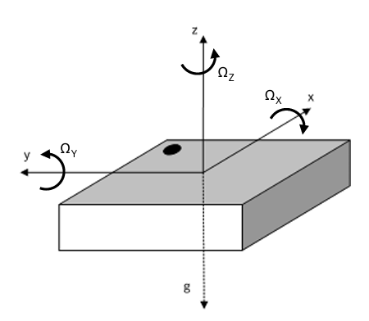

* 16-bit 3-axis accelerometer with ±2g/±4g/±8g/±16g range
* 16-bit 3-axis gyroscope with ±125dps/±250dps/±500dps/±1000dps/±2000dps range

BMM150

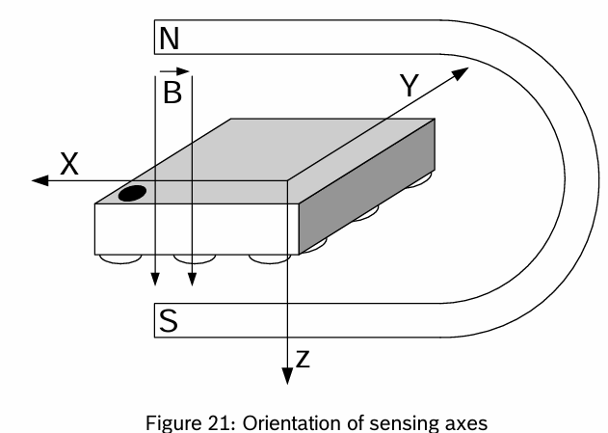

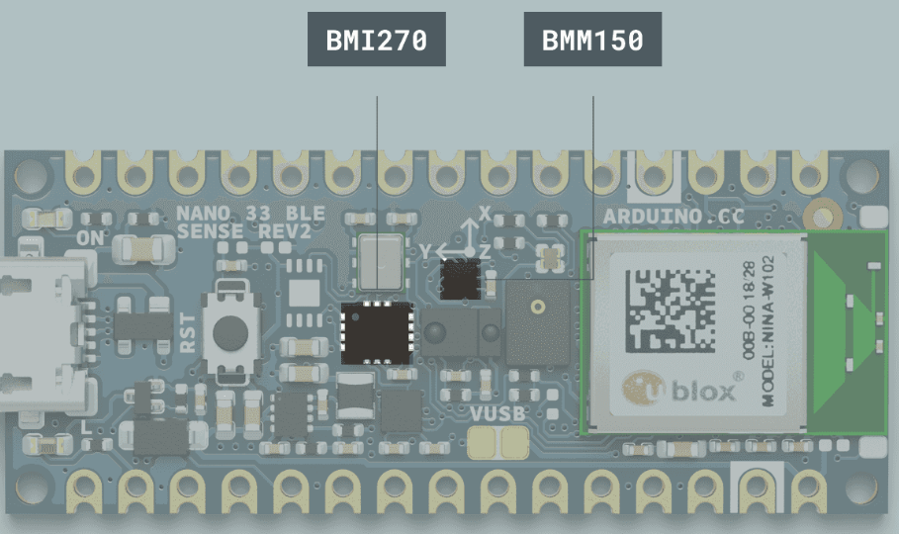

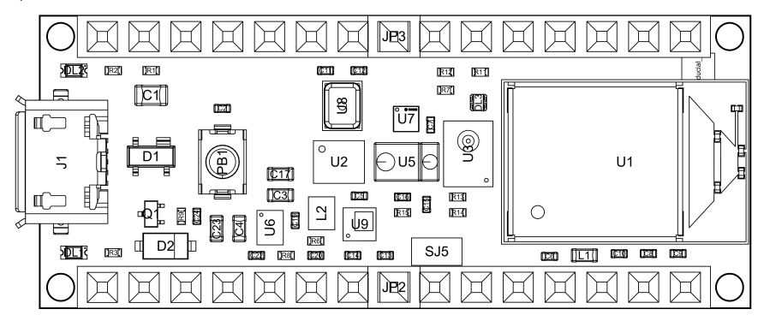

[BLE Sense Rev2 IMU & Magnetometer Sensor Fusion - values drift, what is the correct axis orientation for BMI270/BMM150? - Nano Family / Nano 33 BLE Sense - Arduino Forum](https://forum.arduino.cc/t/ble-sense-rev2-imu-magnetometer-sensor-fusion-values-drift-what-is-the-correct-axis-orientation-for-bmi270-bmm150/1290027)

[**jremington**](https://forum.arduino.cc/u/jremington)

1[How to calibrate sparkfun mpu9250 - Using Arduino / Sensors - Arduino Forum](https://forum.arduino.cc/t/how-to-calibrate-sparkfun-mpu9250/968616/5)

[Mar 2022](https://forum.arduino.cc/t/how-to-calibrate-sparkfun-mpu9250/968616/6)post #6

https://avatars.discourse-cdn.com/v4/letter/m/ee7513/48.png mi5t3r_m:

My question is where can I find those gain factors for the sparkfun mpu9250?

For magneto, the "norm H" value is arbitrary, as none of the AHRS programs care about the absolute value of the magnetic field strength. They use only the direction of the magnetic field vector, and for input to the Mahony or Madgwick filters, the vector should be normalized (if it is not normalized elsewhere).

For Magneto, choose a value for the norm so that the diagonal correction matrix elements end up being about 1. The average magnitude of the input field vector is a fine choice.